FINANCIAL SERVICES
Power BI Dashboard Analysis Report
Executive Overview • Customer & Account Analysis • Loan Analysis • Transactions & Branches

Prepared by: Harshitha C
Programme: BCom Fintech with AI — AMET University
Tool Used: Microsoft Power BI
Date: August 2026

1. Introduction
This report presents an analysis of a four-page Power BI financial services dashboard covering executive performance, customer and account activity, loan portfolio health, and transaction and branch operations. The dashboard consolidates data on 720 customers, roughly 2,000 accounts, 330 loans, and 50,000 transactions across approximately 50 branches operating primarily in North America and Europe.
The purpose of this report is to walk through each page of the dashboard, interpret the key metrics and visuals it presents, and draw out the business insights, risks, and data-quality observations that emerge from the analysis. Recommendations for improving both the underlying data and the dashboard design are included at the end of this report.

1.1 Objectives
- Summarise the key performance indicators (KPIs) presented on each dashboard page.
- Interpret trends in loan performance, account balances, and transaction volume.
- Identify data quality issues and anomalies visible in the visuals.
- Provide actionable recommendations based on the findings.

1.2 Scope and Tools
The dashboard was built in Microsoft Power BI using four report pages: Executive Overview, Customer & Account Analysis, Loan Analysis, and Transactions & Branches. Visual types used across the dashboard include KPI cards, donut charts, clustered bar charts, line charts, a filled map, and matrix/table visuals, supported by slicers for Year, Account Type, and Account Status.

2. Executive Overview
The Executive Overview page is the landing page of the dashboard and gives a top-level snapshot of the bank's overall financial position.
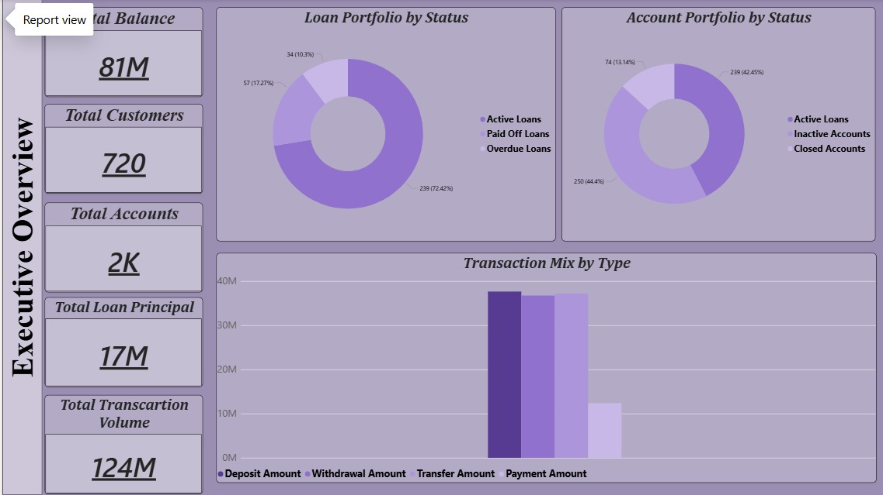
Figure 1: Executive Overview page

2.1 Key Performance Indicators
Metric | Value
Total Balance | 81M
Total Customers | 720
Total Accounts | 2K
Total Loan Principal | 17M
Total Transaction Volume | 124M

2.2 Loan and Account Portfolio Mix
- Loan Portfolio by Status: Active loans dominate the book at 239 loans (72.4%), with paid-off loans at 57 (17.3%) and overdue loans at 34 (10.3%). A double-digit overdue share is worth monitoring closely, as it sits above the low single-digit overdue rates typically targeted by retail lenders.
- Account Portfolio by Status: 239 accounts are shown as active (42.5%), 250 as inactive (44.4%), and 74 as closed (13.1%). Note that the legend on this chart labels all three categories as “Loans” rather than “Accounts” — this is a labelling inconsistency in the dashboard rather than a data issue, and should be corrected for clarity (see Section 7).
- Transaction Mix by Type: Deposits, withdrawals, and transfers are broadly balanced at roughly 36–38M each, while payments trail at around 12M. This suggests the customer base uses the bank primarily for saving and moving money rather than for bill payments.

3. Customer & Account Analysis
This page breaks down account balances and customer composition across five account types: Business, Youth, Savings, Checking, and Payroll.
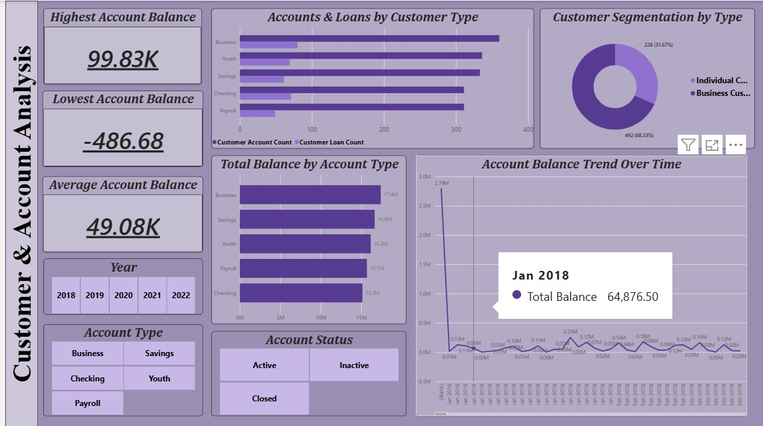
Figure 2: Customer & Account Analysis page

3.1 Balance Extremes
Metric | Value
Highest Account Balance | 99.83K
Lowest Account Balance | -486.68
Average Account Balance | 49.08K

The negative minimum balance (-486.68) indicates at least one account is overdrawn. While a single account, this is a signal worth flagging for the collections or risk team, since unmanaged negative balances can indicate financial distress or account misuse.

3.2 Customer Segmentation and Balance Distribution
- Customer Segmentation by Type: Business customers account for 492 of the customer base (68.3%), against 228 individual customers (31.7%) — a business-skewed portfolio.
- Total Balance by Account Type: Balances are fairly evenly spread: Business (17.4M), Savings (16.6M), Youth (16.2M), Payroll (15.7M), and Checking (15.1M). No single account type dominates, indicating a diversified deposit base.
- Accounts & Loans by Customer Type: The bar chart shows account counts consistently outnumbering loan counts across all five categories, meaning most customers hold a deposit account without necessarily holding a loan — an opportunity for cross-selling lending products.
- Account Balance Trend Over Time: The trend line shows a sharp spike to 2.79M in January 2018 that is not repeated in any later month, after which balances settle into a much lower, noisy range (roughly 0.01M–0.25M per period). This early spike looks like an outlier or a data-loading artifact rather than genuine business activity, and warrants a data quality check (see Section 7).

4. Loan Analysis
The Loan Analysis page focuses on the health and performance of the loan book of 330 loans.
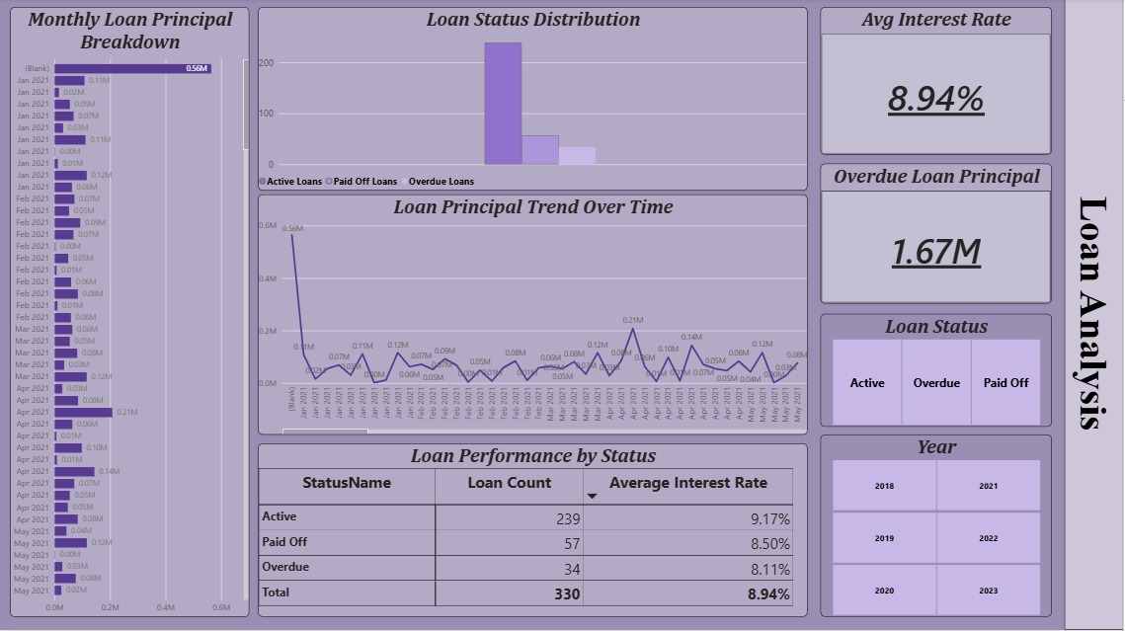
Figure 3: Loan Analysis page

4.1 Loan Performance Summary
Status | Loan Count | Avg. Interest Rate
Active | 239 | 9.17%
Paid Off | 57 | 8.50%
Overdue | 34 | 8.11%
Total | 330 | 8.94%

4.2 Observations
- Overdue exposure: Overdue loans carry a principal of 1.67M, which is roughly 9.8% of the 17M total loan principal reported on the Executive Overview page — consistent with the 10.3% overdue share seen there.
- Interest rate pattern: Overdue loans carry the lowest average interest rate (8.11%) of the three categories, while active loans carry the highest (9.17%). This is somewhat counter-intuitive, since higher-risk or distressed loans often carry higher, not lower, rates; it may be worth checking whether interest rate and loan status are being captured independently or whether older, lower-rate loans are more likely to have gone overdue.
- Loan Principal Trend Over Time: Similar to the account balance trend, there is a large opening spike (0.56M in January 2021) followed by a much lower and fairly stable monthly range (roughly 0.01M–0.21M), with a secondary local peak in April 2021 (0.21M). This recurring “spike-then-settle” pattern across two different trend charts (Sections 3.2 and here) suggests a shared, systemic data issue rather than two unrelated one-off events.
- Monthly Loan Principal Breakdown: The granular monthly bars (Jan 2021–May 2021) confirm the same pattern at a finer level, reinforcing that early-period values are consistently overstated relative to the rest of the series.

5. Transactions & Branches
The final page analyses the volume and geography of the bank's 50,000 transactions worth a combined 123.96M, spread across roughly 50 branches.
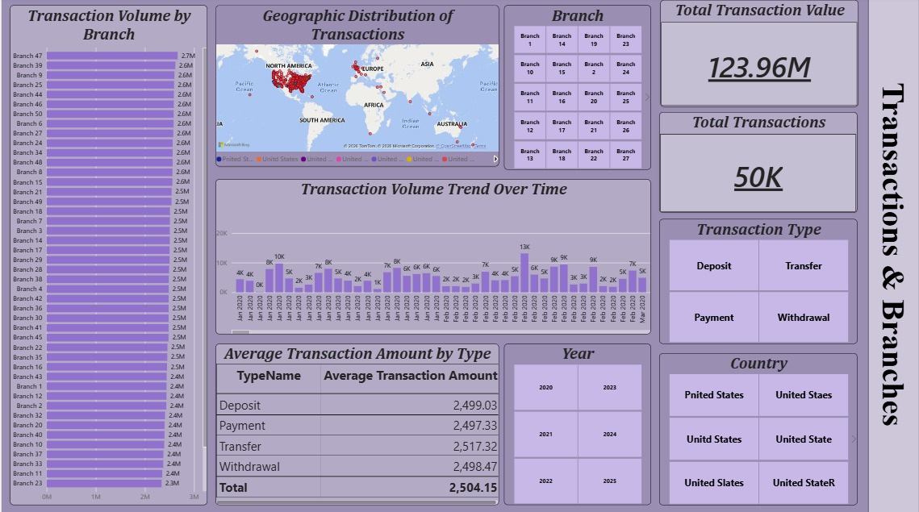
Figure 4: Transactions & Branches page

5.1 Transaction Summary
Metric | Value
Total Transaction Value | 123.96M
Total Transactions | 50K

5.2 Branch and Type Breakdown
- Transaction Volume by Branch: Volume is remarkably even across branches, with the top branch (Branch 47) at 2.7M and most others clustered between 2.3M and 2.6M. This even spread suggests transaction activity is either well-distributed geographically or (more likely for a generated/test dataset) allocated near-uniformly across branches by design.
- Average Transaction Amount by Type: Deposit (2,499.03), Payment (2,497.33), Transfer (2,517.32), and Withdrawal (2,498.47) all average close to 2,500, giving an overall average of 2,504.15. The near-identical averages across all four transaction types again point to a uniformly generated dataset rather than organic customer behaviour, where transaction types typically vary more in size.
- Geographic Distribution: The map shows transaction activity concentrated in North America and, to a lesser extent, Europe, with minimal presence elsewhere — consistent with a bank whose branch network is concentrated in these two regions.
- Country data quality: The Country slicer lists at least five visibly misspelled variants of the same country — including “Pnited States,” “United Staes,” “Unitd States,” “United Slates,” and “United StateR” — alongside the correct spelling. This is a clear data entry/standardisation issue: these should be a single value, and as it stands, any filter or slicer selection on “United States” will silently exclude the other misspelled variants. This is the most significant data quality issue found on the dashboard.
- Transaction Volume Trend Over Time: Monthly volume fluctuates mostly between 2K and 10K transactions, with a single sharp peak of 13K, without a clear seasonal pattern in the window shown.

6. Cross-Page Insights
- Consistent overdue signal: The 10.3% overdue loan share on the Executive Overview page, the 1.67M overdue principal on the Loan Analysis page, and the negative minimum account balance on the Customer & Account Analysis page all point in the same direction: a segment of customers under financial stress that would benefit from a dedicated early-warning or collections view.
- Recurring “opening spike” pattern: Both time-trend charts that begin their series (account balances in Section 3.2, loan principal in Section 4.2) show an outsized first data point followed by a much lower, stable range. This pattern appearing twice, independently, strongly suggests a systemic issue — such as an opening “bucket” that absorbs all unassigned or blank-dated records — rather than two coincidental anomalies.
- Business-heavy, deposit-led customer base: 68% of customers are businesses, and account counts outnumber loan counts across every account type, suggesting the bank's current relationship with most customers is deposit-based rather than credit-based. This represents room to grow the lending side of the relationship.

7. Recommendations
- Correct the mislabeled legend on the Account Portfolio by Status donut chart (Section 2.2), which currently reads “Active/Inactive/Closed Loans” for what are account statuses.
- Standardise the Country field so that all five misspelled variants of “United States” are merged into one value, ideally at the data-source or ETL layer using a lookup/mapping table rather than in the report itself.
- Investigate the opening-period spikes in the account balance and loan principal trend lines to confirm whether they reflect a genuine one-off event, a “(Blank)” date bucket, or a data-load error, and correct or footnote the charts accordingly.
- Add a risk/collections view that combines overdue loan principal, negative account balances, and interest-rate-by-status in one place, given how closely these three signals track together across the current pages.
- Review interest-rate logic for overdue loans, since it is unusual for the overdue segment to carry the lowest average rate of the three loan statuses.

8. Conclusion
Overall, the dashboard provides a clear, well-organised view of a mid-sized bank's balance sheet, customer base, loan book, and transaction activity, using an appropriate mix of KPI cards, donut charts, and trend lines across four focused pages. The loan portfolio is dominated by active loans but carries a notable 10.3% overdue share worth monitoring, the customer base skews toward business accounts with more deposit relationships than lending relationships, and transaction activity is evenly spread across branches concentrated in North America and Europe. The most actionable finding from this analysis is the set of data quality issues — the mislabeled account-status legend, the fragmented Country field, and the unexplained opening-period spikes in two separate trend charts — all of which are straightforward to fix and would materially improve the reliability of any conclusions drawn from this dashboard going forward.

